Mimics of Everyday Life
Edith Garcia

I grew up in El Paso, Texas, surrounded by mountains, engulfed in the heat of the desert, suffocated by air embedded in grit, sand and dirt. As a child I would wait for the rain to hit and break the Texas heat, staring out of the window, patiently awaiting for these molten islands of mud to appear across the landscape. As they formed I excitedly knew that I would spend countless hours in them, creating astounding unimagined worlds within that playground of dirt, and when the sun rose I would rush out to construct microcosmic civilizations of tiny human figures, mimicking everyday life. Later they would dry in the shimmering sun and survive only as long as the next rain fall.

Today in my studio in some ways I am still creating these minute civilizations, but in place of the primitive mud and dirt, pen and paper now capture these imagined worlds, giving rise to sketches that are transformed into figurative works. My everyday life continues to feed my artwork, stimulating, encouraging, and motivating me.

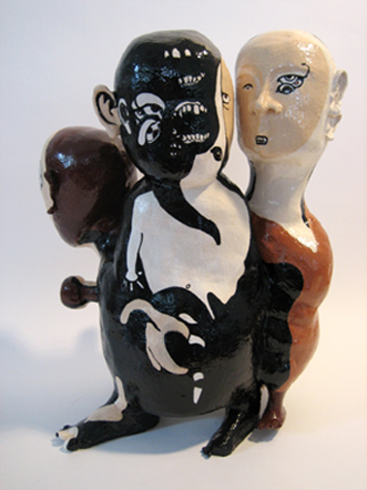
I have always been more intrigued by experiences that resonate, those moments that leave a metallic aftertaste in our mouths that remind us that we are alive. I have a taste towards the darker side of life, and not the crime scene scenarios of Hollywood movies, but those incidents that keep us more in tune with our animal instincts, events that represent a dysfunctional society at large. My work often reflects the darkness and fear a child can experience within their home. Less focused on global issues, I’m more fascinated by what happens in the surrounding neighbourhood, a place where things can go wrong.

Though the home is commonly perceived as comforting and reassuring I am fascinated by the tragedies of everyday life, where there is a tendency for people to condemn themselves to a world of darkness and confusion, by succumbing to violence and the desire to control others. My work is fed by the daily onslaught of emotional extortion we endure and the minimal occurrences that transpire each day, breaking these moments down and translating them into figurative objects and installations, creating figures that are grotesque, enfeebled, flamboyantly unappealing, burdened with a woe out of all proportion to evident circumstances.

Each piece exists in its own private world, born from conscious and unconscious decisions made during the creative process. Much of my work is thematically oriented, capturing moments that are pushed aside and infrequently discussed. Using the sketches I imagine how I will bring the works to life, sculpting with my mind and my hands, intuitively open to suggestions from the material as well as with reference to my drawings, responding to the fragility and delicacy of the material itself.

With the OtraVez series and my most current work, the B+2 [Brutal Beauty Series], the sculptural building is the part of the process that seems to occupy the most amount of time, yet is the element that feeds the work until it is complete. When I finish sculpting a work I take time to live with it and let it tell me a “story” or to let it help me in telling how it should be decorated. Should I draw onto it images that create an illusion of other figures? Or paint images that directly relate to the sculptural form?

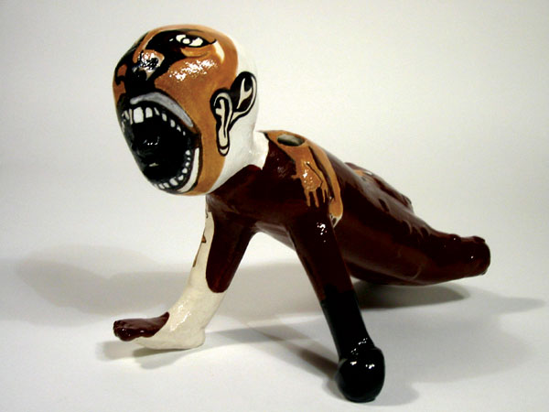
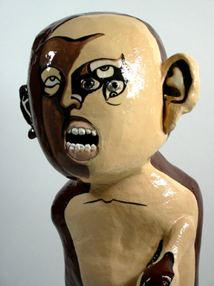
Depending on the level of delicacy the decorating can take as long as it does to create the physical sculptural form. I usually sketch the raw sculptural outline and superimpose images onto the figure to see what they can contribute. It usually takes several sketches to finally resolve the imagery that I will wish to use, and only then am I ready to begin the task of painting visual images onto the sculptural forms. The paintings add to the visual experience of the work. At times the most effective way forward is to simply let the form itself tell the story, but in applying imagery on top of the forms it creates a relationship between the object and the surface itself, presenting a secondary dimension in which to immerse the viewer, beyond the physical item, its linear trajectory interspersed with patterns and shapes on the surface.

Moving away from representing the human form in a conventional manner has brought a new freedom to my work. In re-interpreting the human figure in this way, I'm able to create forms that de-mystify the body and create a physical continuity between the inner intangible and outer tangible aspects of the human form, erasing features, subtracting limbs, expanding the scale, moving beyond the familiar.

By changing what nature dictates and erasing the boundaries of what the natural world intended has taken my vision to another level, exploring new ways to extend the body in sculpture, and in so doing creating a world that reaches beyond the physical and into a world of ideas.

My work has allowed me to observe our everyday world and provoke an audience to consider its peculiarities, anomalies and possibilities. Though no longer a small girl in the scorched desert, I still frequently wait at the window for the falling rain.

EDITH GARCIA

