EVENTual BodieSpaces

Fiona Fell

EVENTual BodieSpaces is a series of works and related papers that focuses on the reciprocal relationship between the performative body in and around an affective space (fig. 1). Research for this paper comes from my master’s thesis completed

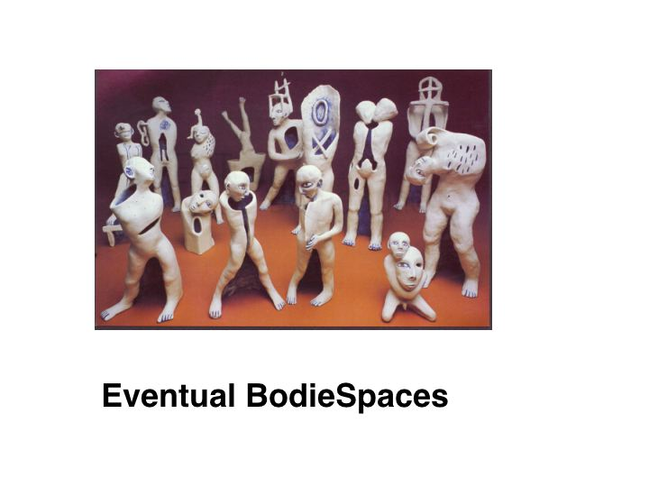
[Fig 1]

in 2000 which was accompanied by an installation of porcelain figurines in a structural environment. This research also includes discussion into recent projects and investigations of fragmentation of the figure. Throughout this paper I employ the term ‘body’ as a reference to pluralistic bodies, which integrate both corporeal and metaphysical. I ask the questions, ‘What happens to meaning when the body is fragmented or modified by architectural elements and structural devices?’ and ‘How is the fictive body formed through fragmentation?’

These contemplations reveal narratives of personal history, ‘body memory’, and speak of the way I inhabit my body. <fig. 2 near here>.

The way I inhabit my body | The way I extend my body | The way I describe my body
The way I investigate my body | The way I carry my body | The way I conceal my body
The way I dislodge my body | The way I reject my body | The way I restrict my body
The way I measure my body | The way I fool my body | The way I subject my body
The way I neglect my body | The way I place my body | The way I pleasure my body
The way I exploit my body | The way I force my body | The way I revolve my body.
The way I assemble my body | The way I adorn my body | The way I dissolve my body
The way I conduct my body | The way I abuse my body | The way I disfigure my body
[Fig 2]
This body of work was installed in three different spaces. Figure 3 is a detail from a show at Object Gallery, Customs House, Circular Quay, Sydney, Australia. The thirty-five figures were placed on a 12 metre single shelf on a wall. The figures formed a line in a hieroglyphic manner. Reminiscent of an ancient language of gesture and narration, the work explores a new form of gesturing using negative space. It looks at the way the body houses emotions and the memory of events.

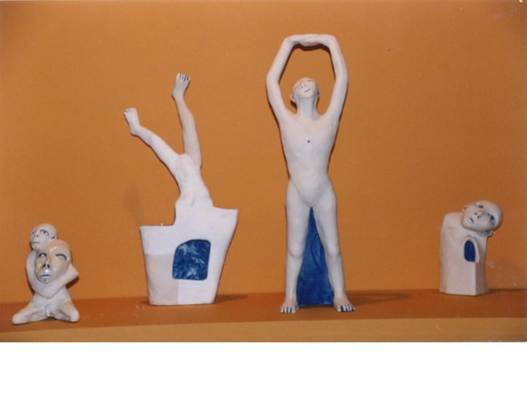
[Fig 3]

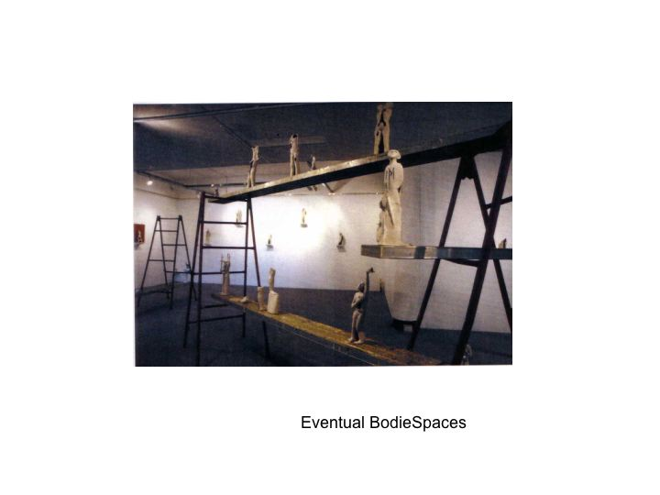
[ Fig. 4]

In the second installation space the work was installed in such a way as to create two contrasting spatial formats (fig. 4). One part used shelves on the walls in a central section of the gallery. Placed in the corners of this space are two pieces, one displayed too high for the viewer to engage on eye level and the other piece too low. The second part of the installation engaged in the temporal space of the gallery through sets of industrial scaffolding, trellises, and planks. In the use of the trellises I created a spatial sequence that constituted a specific environment.

These structures act metaphorically as paradigmatic boundaries, the total installation suggesting a restoration site. The trellises create spaces that assist in the integration of the gallery space and the subject, the subject being the figures in their various states of restoration.

The departure from the use of plinths and the decision to work in series instead of with individual work reveals insights into the way narrative is constructed as a direct result of the interactivity between the figures and the space within which they are viewed.

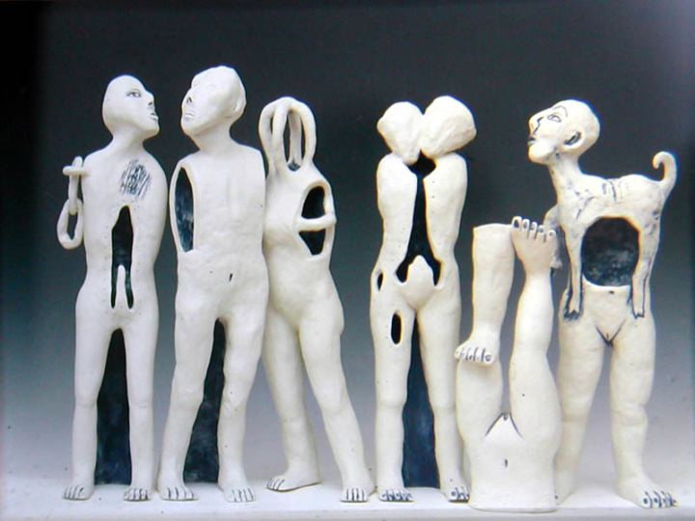
[Fig5]
Negative space is evident in each piece, accessing the inside volume of the figure (fig. 5). Meaning is conveyed when negative spaces assume the role of gesture in a revised extended function signifying ideas about the absent body. These figurines therefore are gesturing through the spaces in their bodies to speak of unconscious moments and memories of places fragmented. They embody memories of situations in which I have felt hollow and disconnected, corners to which I have retreated to feel safe, and moments of extreme self-consciousness.

A favourite game of mine as a child was the card game or book of interchangeable features. Versions of this game date back to the early nineteenth century and were usually in the form of lithographs coloured by hand.¹ In this game any head would fit any body or legs with comic effect and countless variations.

A more sophisticated and sinister version of this game is found in the Australian author Peter Carey’s short story entitled ‘Chances’.² In this story he describes characters who take pills and disfigure their bodies as part of a game of genetic lottery. In the story a trend spreads through a Bohemian group of actors, models, artists, and writers. A subculture emerges out of an attraction toward distortion and the dismantling of the dominant paradigms of beauty. The new bodies these characters manufacture give them access to the body memory of other people. Carey’s story illustrates a human fascination with the idea of symbolic occupancy of another’s body.

Another example of how the idea of assembling the body is used can be found in the work of Australian artist Fiona Hall. In the making of her Morality Doll she turns her obsession with Bosch and Brueghel into cut-outs of body parts in the process of assemblage. This disfigurement of the human form is a result of looking at the social body as she concentrates on basic human flaws in an examination of the Seven Deadly Sins derived from the five senses and known in Eastern philosophies as the five thieves.

The history of figuration and its social discourses has touched on feminist perspectives concerning the politics of the body. Dialogues concerning internal spaces and the relationship between the vessel and the figure were considered in this body of work. The work of contemporary American artists Michael Lucero and Sergei Isupov describe vessel/body relationships, addressing notions of the assembled body. Both Isupov’s and Lucerno’s work operates as interactive visual systems that rely on the energy exchange between the parts that make up the whole. Their work is made of singular objects suggesting function but all the activity occurs inside the figures, which are characterized by their internal machinations.

Figurative work in ceramics has often alluded to forms of the functional yet transcends the form by its play with gesture and narrative devices. Through research into the nature of figurines and dolls and through the processes of making I have become interested in the way figures embody internal narratives, notions of body memory, and votive functions of the fictive body. I use the term ‘fictive body’ to describe representations of bodies that generate pluralistic concepts based around the narrative.

My own practice and research in the field of figuration led me to California, USA, where the ceramic figure operates in a strong established genre. A continuation of the 1960s funk ceramics movement, every year the California Conference for the Advancement of Ceramic Art reinforces the world of figuration through the participation of artists and the John Gastrulas Gallery in Davis. A group exhibition of thirty figurative ceramic artists in which my work was included enabled me to immerse myself in the issues of contemporary figuration.

The work The Only Ember (fig. 6) provides an example of how concepts concerning narration and the role of the fictive body are employed in my work. This piece was made as a response to the refugees of Kosovo who had returned to their homes after the fighting to find their houses destroyed and burnt to the ground. This particular work is significant as a transitional piece as it divides the body into spaces that suggest a building or site where significant drama has taken place. The figure is constructed like the exoskeleton of a house that has just burnt down. It is held together by a small golden figure standing inside the skeletal form; the burnt chair is the only remaining piece of furniture. In this example, the figure becomes a vehicle for telling stories in the way it uses key symbols as a narration device in combination with surface. The visual devices I have used to open up the forms, assessing the inside volume of the pieces, help to introduce psychological fragmentation as a major component of the work.

. 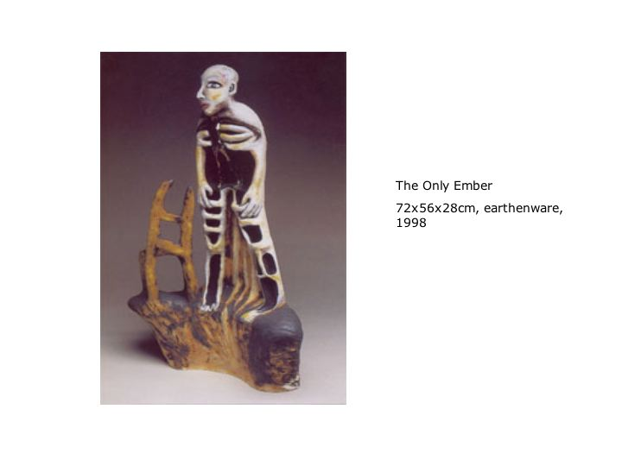
[Fig 6]

Mimo Paladino’s figurative sculptures offer interesting examples of the way figures can embody narratives. A series of figurines seen at a retrospective of his work at Fort Belvedere in Florence was installed with the impressive backdrop of the city of Florence and the Tuscan hills. Paladino’s use of narrative, gesture, interactivity between figurative elements, and the varied surfaces he applies to his sculptures have been a major influence on my work.

In one sense, deep cultural memory particularly survives through the significance of gesture – the position of the arm and the hand, the language of the eyes, the sense of posture, of pushing, holding, touching, these are matters touched on by the art and specifically by the sculptures of Paladino.³

A work period and residency in Toki, Gifu prefecture, Japan, brought me close to Butoh and Noh theatre where ghostly deities and animistic traditions made a continuing impression on me. Butoh, which is generally considered to be a performance art, also speaks of body as fiction. This concept is extended to embrace notions of cultural body memory and addresses the issue of how narrative is manifested through the interactivity of the corporeal and the metaphysical. Butoh philosophy rebels against the domesticated body. Rather than restricting the body to the routines and spatial constraints of an interior, its aim is to create a form that can embody the emotional forces that determine our lives on both a grand and minute scale.

Sometimes I feel I can describe my body without my own body. First of all, you have to kill your body to construct your body as a larger fiction and you can be free at that moment. It happens when you think about this concept that fiction equals a body. It is not only massive but light and transparent. What does this fiction consist of?

This fiction is almost chaos, catching some parts of chaos and creating a total chaos. You can find many different cells in each part of your body. And you can build a bridge between one cell and the other. You have to have a shape of a human being. You can be a whole city. Having a disease sometimes makes a building more attractive.⁴

The work and writings of Antony Gormley also inform my understanding of this concept. Gormley reveals to us the strengths and expanse of the inside world in relation to outside spaces by siting many of his life-size pieces in unusual architectural settings and in landscapes. ‘This practice invites the community at large, and not just the individual, to inhabit their inner spaces.’⁵

Gormley also used the form of his own body to create sculptures that explore ideas of encasement. The figures are entombed in lead and give the impression of an embalmed body where the casing provides protection to the inside space.

Louise Bourgeois extends architectural metaphors when she refers to the house as a place of conflict. A drawing by the artist made in 1946 entitled Women House shows a woman with a house as a head; her body is left exposed and vulnerable.

I thought let them come unhouse me of my flesh, and pry this house apart.
It was no shelter now, it only kept me here alone.⁶

I have used metaphors of the house or certain architectural elements extensively in the development of my work. For example the trellis structure in the installation EVENTual BodieSpaces suggests boundaries and corner spaces as well as referring to inside space. ‘Space does not exist, it is just a metaphor for the structure of our existence.’⁷

In a recent trip to Italy I was re-acquainted with the work of Luca Della Robbia. The first delightful contact I made with Robbia’s work was a piece by his wife, Andrea, Foundling in Swaddled Clothes (1487), positioned above an entrance to an apartment at via Tournabourni in Florence, Tuscany. From this image I was overcome with a sense of continuity as only a year or so before I attended a series of art and technology workshops where Michael Girard, the designer of the animation Baby Dance 1 (fig. 7), introduced his new work. The dancing baby and Robbia’s Foundling display obvious similarities in the way both infants exude an adult awareness of stance and movement. The classical and virtual examples of Della Robbia’s Foundling and Baby Dance 1 reinforce the need to re-evaluate images and the spaces they are defined by.

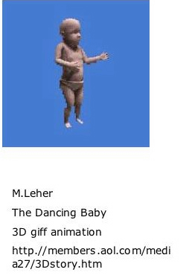
[Fig 7]
The example of the dancing baby, which finds its context in a virtual space, led me to explore the computer and 3D programs as a tool for designing figures. This trajectory led me to look at both contemporary directions in installation as well as how figurative ceramic elements have been integrated into architectural contexts.

At this point in the development of my work I was using a software program called MetaCreations, Poser 3,⁸ to investigate some of the possible combinations and interrelationships of figures. Through working with this program an obsession developed for the way figures move through each other as another process of fragmentation in the distortion of the figure (fig. 8).

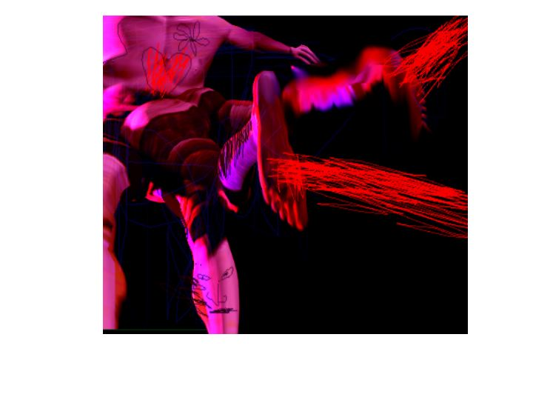
[Fig 8]

This obsession is evident also in the work of Louise Bourgeois.

The way articulation does or doesn’t work is a sign of the way people move together or against each other, the way they relate to each other. It doesn’t have to be sexual connotations. Well the fact is that it is completely sexual – but in an indirect way.⁹

I saw the possibilities of using the program to form initial ideas in the design stages of the work. The images that I created using Poser, as well as expanding my format to include a series of work, helped me to address formal issues such as scale and gesture. The program consists of a warehouse of elements – poses, body types, cameras, and lighting – which are used to assemble the bodies. What interested me was the way I could manipulate bodies so that they could appear to walk through each other, share limbs, and morph with other bodies of both humans and animals. This to me is a virtual expression of classical themes found in Western mythology, for example, creatures such as the Sphinx or centaurs which were created through the incest of the gods. These mythological characters are an example of assembled bodies resulting in transfigurations that are similar to those I was able to produce using Poser as a design process.
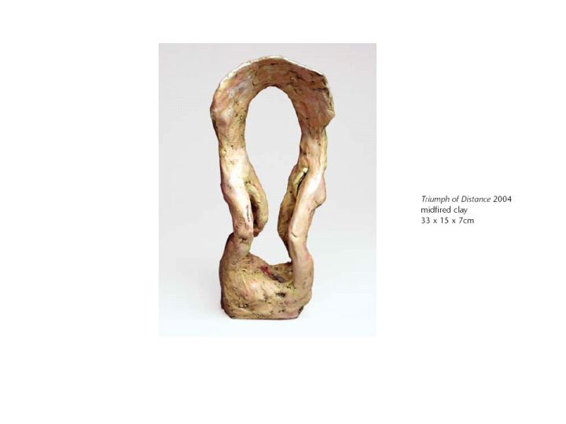
[Fig 9]

A series of figurative sculptures (fig. 9) were made as a result of exploring the program Poser. Through this I looked at the possibilities of how architectural metaphors could be integrated with the figure.

In the field of ceramic figuration, bound by the limitations of the ceramic material, work can be extended by its placement into the surrounding space. For example, a work (such as Della Robbia’s Foundling in Swaddled Clothes) placed in an architectural setting takes on the context of its environment and is therefore transformed within an atmosphere of architectural definition. The viewer is given a more active role in the work.

When strolling through the national museums in Rome and Naples I noted the gigantic sculptures of emperors and gods. The scale of the sculptures reinforced concepts of power and domination. Scale in this context is magnified by the gallery or museum space.

In an essay, ‘Homeopathic Strategies’, for the catalogue of an exhibition of small-scale work and miniature sculptures, Ralph Rugoff suggests that the nature of small-scale work seems to mock the grand spaces in which it is displayed.

To view a very small object or image, we must also surrender the aloofness of gallery flaneurs and instead publicly declare our desire to look. Tiny artworks force us to draw closer in order to scrutinise them, and this forward movement parallels a mental process.¹⁰

I have used small scale in my work as a device to introduce a secondary narrative that either extends the meaning of the larger figure or informs us that another agenda exists. Scale has also influenced my decision to work in a series and consider installation strategies that mimic traditional placements of the decorative or tabletop size. The decision to produce small-scale work was also influenced by a desire to introduce intimacy both as a subject and as a viewing requirement.

Issues igniting the relationship between scale and fragmentation can be found in the work of the American Doug Jeck. Jeck uses scale to magnify the heroic and at the same time manages to invert masculinity by the representation of his particular subject.

Research for EVENTual BodieSpaces has enabled me to explore contemporary issues of fragmentation and the figure as well as the personal and social spaces this genre occupies. Suggested theories of spatial design and psychological space have helped to integrate personal experiences with architectural metaphors.

Investigations into the conceptual underpinnings of design in figuration via the computer program Poser have resulted in an ongoing process to consider site and the possibilities of my own practice to shift emphasis within the genre toward the utilization of installation strategies.

The way I have worked with fragmentation can be described as a form of figurative stylization, a representation of the body as figurine to include dialogues concerning internal spaces. In the process of refiguring my relationship with the issues surrounding the fragmented figure, research into scale, context, and site has nurtured my understanding of this topic and renewed my interest in the conceptual underpinnings of figuration.

Notes
- M. Hiller, Dolls and Makers, London, Weidenfield and Nicolson, 1968, p.49.
- P. Carey, Collected Stories, St Lucia, Qld, University of Qld Press, 1994.
- P. Bitti and P. Benesperi, Mimmo Paladino, Milano, Fabbri Editore, 1993, p.20.
- A. Maro, quoted in J. Viala and N. Masson-Sekine, eds., Shades of Darkness, Tokyo, Japan, Shufunotomo, 1998, p.46.
- J. Hutchinson and E. H. Gombrich, Antony Gormley, London, Phaidon, 1995, p.10.
- M. Robinson, Housekeeping: the Makers Choice Catalogue, Sydney, Craft Realities – Crafts Council of S.A., 1992.
- R. Storr, P. Herkenhoff, and A Schwartzman, Louise Bourgeois, New York, Phaidon, 2003, p.140.
- Poser 3, MetaCreations corp.6303, Carpinteria, California, 93013.
- Storr, Herkenhoff, and Schwartzman, Louise Bourgeois, p.142.
- S. Stewart and R. Rugoff, eds., At the Threshold of the Invisible, New York, Curators Inc, 1996, p.13; S.Stewart, On Longing, On Narratives of the Miniature, the Gigantic, the Souvenir, the Collection, London, Duke University Press, 1993, p.45.

Bibliography

Bacci, M., European Porcelain, London and Milan, Hamlyn Publishing, 1969.

Bachelard, G., The Poetics of Space, Boston, Beacon Press, 1969.

Collins, J., Architectures of Excess: Cultural Life in the Information Age, New York and London, Routledge, 1995.

Descartes, R., Meditations on First Philosophies, London, Cambridge University Press, 1986.

Feher, M., Fragments of the Human Body, Part 2, New York, Zone, 1989.

Gentilini, Giancarlo, Francesca Petrucci, and Fiammi Domestici, Della Robbia, Florence, Giunti Gruppo Editoriale, 1999.

Grosz, E., Volatile Bodies: Towards a Corporeal Feminism, St Leonards, Australia, Allen and Unwin, 1994.

Grosz, E., Sexuality and Space, New York, Princeton Architectural Press, 1992.

Hutchison, J., E. H. Grombrich, and Lela B. Njatin, Antony Gormley, London, Phaidon, 1995.

Koloski, A. O., and C. L. Lyons, Naked Truths, London, Routledge, 1997.

Nast, H. J., and S. Pile, Places Through the Body, London and New York. Routledge, 1998.

Nochlin, L., The Body in Pieces, Walter Nuerath Memorial Lecture, London, Routledge, 1994.

Puludin, A., Chinese Tomb Figurines, New York, Oxford University Press, 1994.

Stewart, S., On Longing, on Narratives of the Miniature, the Gigantic, the Souvenir, the Collection, London, Duke University Press, 1993.

Yamada, S., New Directions in Paper Craft, London, Pitman Publishing, 1967.

