Barvas Ware: A study of the life and work of the women potters of Barvas, Isle of Lewis, the Outer Hebrides.
Kate Wilson

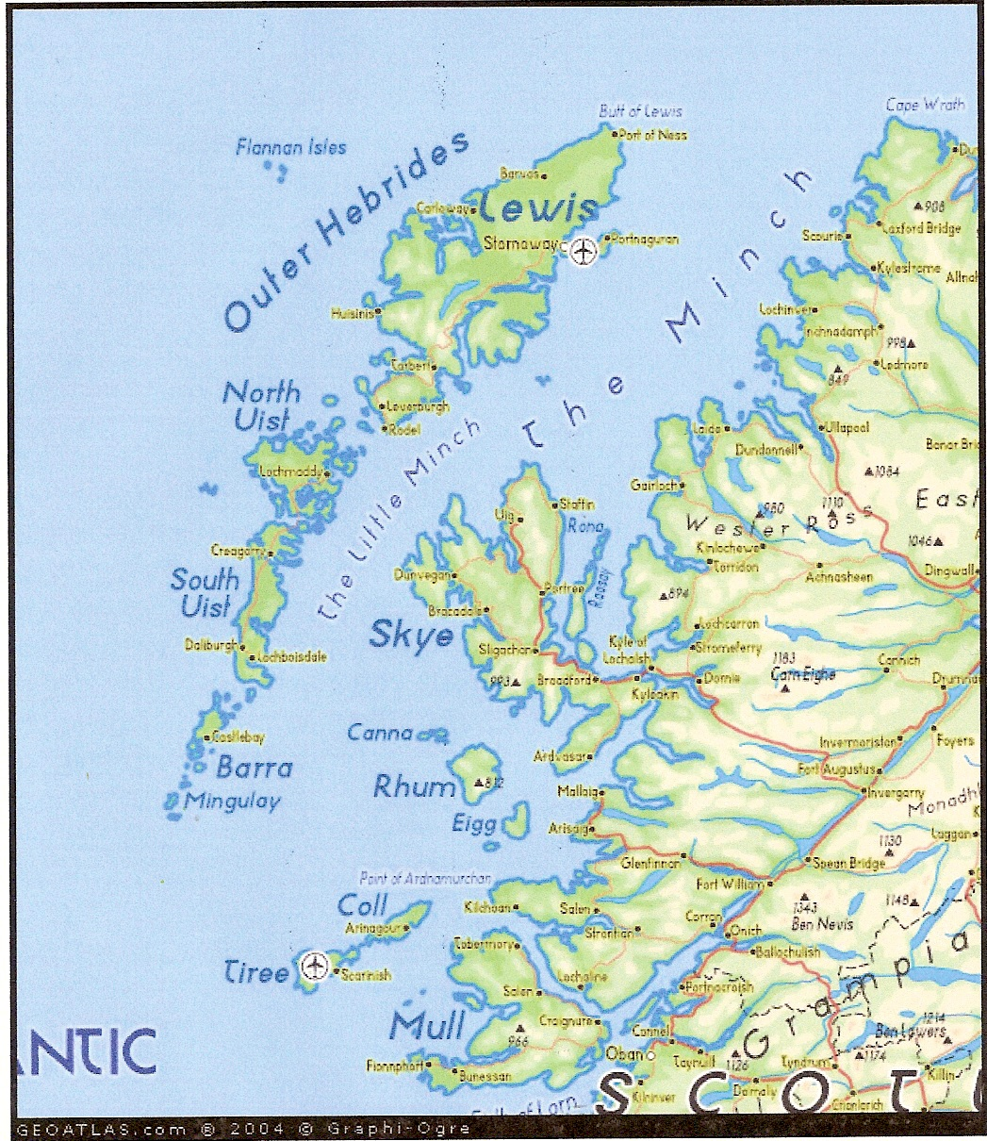

<a href=http://www.map-of-uk.co.uk>Map of UK </a> by Tourism Maps Copyright 2003.

Abstract
The stimulus for this study arose when I noticed a brief mention of Barvas Ware on a visit to a travelling museum in the Scottish highlands where artefacts of Western Scottish folk life from the MacDougall Trust collection, were on display. Although not on show, I was intrigued by the description of a type of pottery produced, specifically, by the women of Barvas, in the Outer Hebrides. Generations of women, though few in number, produced low-fired ceramic vessels known as craggans (or crogans). From the middle of the nineteenth century with the development of travel and tourism some potters began to cater for a new market and made tea sets which sold as ‘curios’ to outsiders interested in island life. The production continued into the twentieth century, but with few potters and an industry dependent on a particular type of collector, making ceased by the 1930s. This study considers the life and work of the women potters of Barvas and acknowledges their skill and enterprise during a time of economic and social hardship.

Key Words
Barvas Ware, craggans, tea sets, women potters, Hebrides

Introduction
The pottery vessel known as a ‘crogan’ or ‘craggan’ was made in Lewis and other parts of the Hebrides for around seven hundred years. It is likely that craggans were directly linked to Norse pots of the thirteenth and fourteenth centuries, a time when the north and western isles were occupied by people from Scandinavia. Unglazed and characteristically spherical in shape, ‘craggans’ (See Fig.1) were a type of vessel used to contain food stuffs and fish oils for lamps, as well as milk products, and were sometimes associated with curative properties for consumption. They were fired in the peat hearths of the family crofts. Due to the scant availability of wood, craggans were likely to be in use for far longer on Lewis as opposed to mainland Scotland, where wooden vessels and utensils were more widely used.

However, during the 1800s when other cultures began to have an impact on their lives, the women started to produce naïve copies of lowland Scottish pottery and Staffordshire Wares. They made teapots and cups and saucers produced, predominantly, for sale on the mainland (fig.2). As with the craggans, they were dried by and fired in their hearths and sealed with milk.
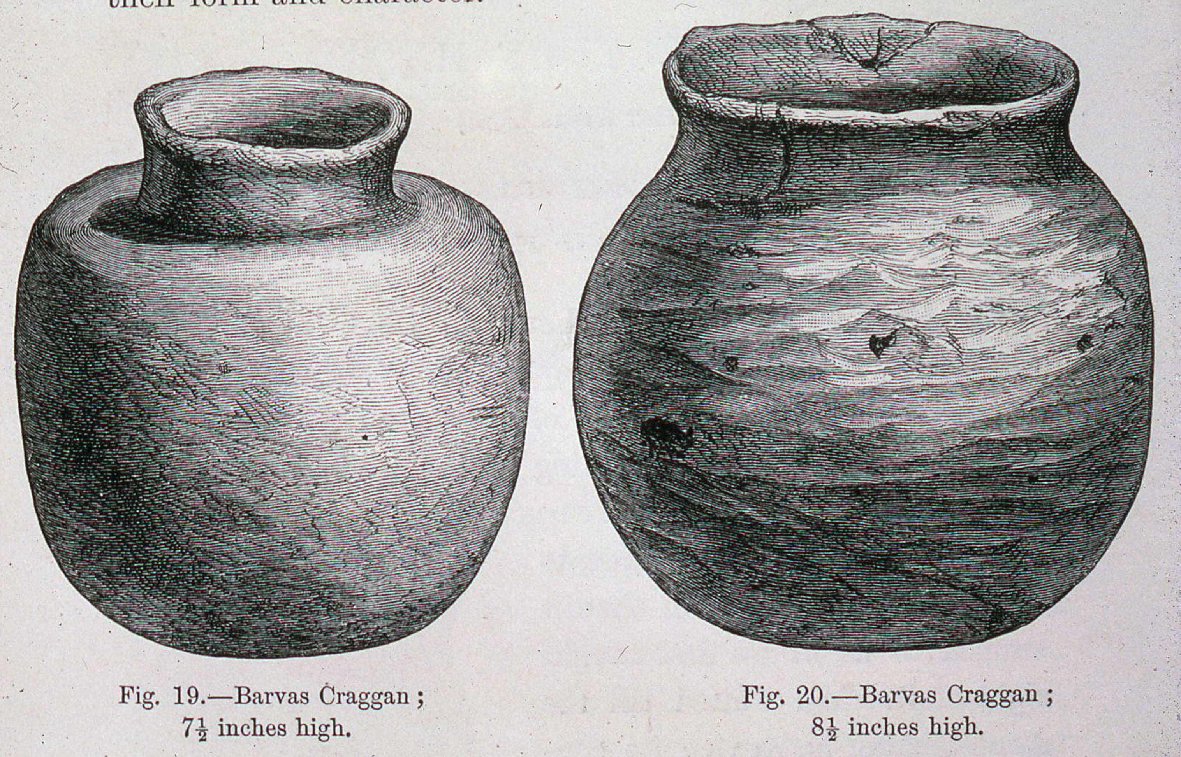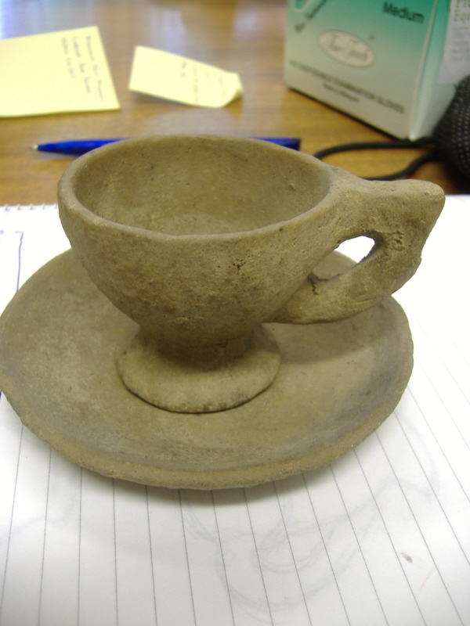

Fig.1 Fig. 2

After the First World War the tradition gradually died out and the last known maker stopped producing these wares by the end of the 1930s.

The earliest recorded reference of Hebridean pottery making was in 1695 when Martin Martin wrote about food containers produced by women,

The soil is generally sandy….and is in other places a fine red clay as appears by the many vessels made of it by the native women, some for boiling meat, others for preserving their ale, for which purpose they are better than barrels of wood.

However, the most famous and repeated account is from Arthur Mitchell’s book, The Past in the Present, published in 1880. Visiting the island with a Captain Thomas, who also had an interest in antiquity and anthropology, he recalls coming across a stonebreaker on the side of the road eating his dinner out of a vessel which struck them as ‘truly remarkable’. Mitchell bought the vessel from him and was shortly inundated by others offering ‘craggans’ for sale. He commented that they had originally been made in many of the villages on Lewis in the past but at that point (1863), they were probably only produced in Barvas. A couple of days later he visited the maker,

Expecting a visit from curious strangers, proud of her skill, and anxious to display it, our Barvas potter had prepared for us, in addition to the craggans, some imitations of Staffordshire ware, and some models of animals.

This is the first record of what Mitchell went on to name as ‘Barvas Ware’, the crude copies of factory produced ceramics. Caught up in the passion for anthropology and Darwinism at the time, the Hebrides offered the ‘exotic’ as close to home as was possible and writers such as Arthur Mitchell, fuelled this passion in his book.

By the late 19th century, crogans and Barvas Ware had become well established in the public notice and from the range of written contemporary comment, attitudes to the pottery ranged from amused scorn to genuine interest, from regarding it as a crude oddity to judging it to be a rare and fascinating local variant of Scottish material culture.

The production of pottery ceased finally in the 1930s, unable to be sustained by the few collectors still interested in its production.

Geographical and social history
The geography of the islands has shaped the development of its communities as much as any human influence or, indeed, interference. The complexity of Scottish history cannot begin to be addressed here, but by the end of the Napoleonic Wars the wealthy landowners saw their economic future in sheep and deer, therefore tenants were pushed to the island’s infertile periphery or forced to emigrate. The villages that remained were then reorganised and what land was left was divided into crofts.

The island’s political history and the eventual development of crofting may have had an impact on the production of pottery. It is conceivable that earlier when people were more nomadic in their trans-humance culture that more women made pots as and when they came across clay. In the nineteenth century crofting tenants had a more settled lifestyle and by the 1850s the regular ferry services from the mainland were bringing outsiders to the island in a way not experienced before. At this point there were only a few, possibly three, families making in this area. These were the womenfolk of the MacLeods, the MacDonalds and the MacIvers.

The potters and their making
Crofting dictates a particular lifestyle that is not economically sustainable in itself and so the ability to diversify is intrinsic to its survival. Being the craggan makers for their community, the Barvas potters would have supplemented their income by trading their wares. As mentioned earlier, the women developed the making of ‘tea sets’ from around 1860. It is possible that these also became part of the local economic exchange, although there is little evidence to support this assumption. Whether there was any local interest in the tea sets or not, the women adapted an ancient tradition to create ‘modern’ forms which became integrated into their daily routines. Advertising in Scottish newspapers is evidence of an attempt to create a commercial venture, a diversification from the production of craggans that had been part of their everyday existence for centuries.

By the late nineteenth century other types of vessels came into use, such as enamel pans, sold by local ‘tinkers’ who produced utensils of all kinds. This reduced the need to be so self-sufficient. It also created a new fiscal system for communities away from the main town, where for centuries the main economic exchange would have been eggs and other croft produce. As more and more goods became available the need for money became a necessity rather than a luxury. Homes were more permanent and as communication and trade developed with the mainland, taste and the desire for domestic display began to change. The islanders, both men and women, became temporary migrant workers for part of the year. Initially ‘following the herring’, but also later working on the mainland in domestic service. This provided money and allowed homes to gather

cottons from Manchester, crockery from Staffordshire, cutlery from Sheffield, sugar from the West Indies, tea from China and tobacco from Virginia.

Even with all these commodities available it is apparent that craggans, in particular, were still used in Barvas homes for decades after larger communities had ceased use of them. However, by 1877 a Mr D.I.Nicholson, who lived in Bragar, Barvas, supplied a Fellow of the Society of Antiquaries in Edinburgh, the Rev Duns, with a small craggan made by Flora MacDonald. In a letter dated 20 September of that year, he indicated that the pottery had been made to order and that they had stopped using craggans some years previously.

The physical distance between Barvas and Stornaway was nothing compared to the cultural gap by the mid 1800s. In 1863, Mitchell, on his return to Stornaway with his stonebreaker’s craggan, remarked

when Capt Thomas and I reached Stornaway with our treasure, and exhibited them in the hotel, we found that the craggan was nearly as great a curiosity there as it afterwards turned out to be in the south.

Nicholson’s comment was written some fourteen years after Mitchell had discovered the stonebreaker’s vessel, but three years before he (Mitchell), had published his writings. It is therefore likely that between the initial interest from outsiders in 1863 and Nicholson’s provision of a craggan to the Rev Duns in 1877, local usage of the vessels had indeed dwindled. It could then be assumed that during this period of time the women potters of Barvas, regarded as a curiosity by increasing numbers of visiting outsiders, were able to diversify by adapting their skills to create a new trade, producing craggans and tea sets for tourists, sustaining a dying craft for many years beyond local demand and its functional necessity.

John MacDonald, a relative of Flora MacDonald and Mary Murray, recounted that when Flora had made the wares

she would walk the dozen or so miles to Stornaway, and exchange the half sets for groceries. The tea sets were bought by tourists.

The potter that Arthur Mitchell was introduced to in 1863 was a Mrs Macleod. There is a reference in an interview with a Malcolm MacIver , to a croft tenant called Alexander Macleod, a blacksmith. He lived in Lower Barvas and his croft, close to the Torray River, was famous for its clay. I can only assume they were related as these are the only references to Macleods that I have found. All the remaining information collected about the women potters of Barvas relate to Flora MacDonald, her daughter Mary Murray, Mary MacIver and her daughter Catriona Maclean. Mary MacDonald, Flora’s great grand daughter said of her

The way I heard of it in my youth from the people around me and from my father, it was my own great grandmother Flora who was the original potter. She was originally from Dell in Ness but came to live in Park Barvas when she married my great grandfather. Her maiden name was Gillies. She and her daughter Mary started making pottery. They got clay from our own croft just across the stream that runs through it. The clay was very smooth and soft and easy to work with. I heard about them making cups mainly with it. No doubt they made other vessels but I only recall hearing of cups.

She also talks about the ‘baptising of the cups’ which was a big night in the house.

A big peat fire was prepared in the middle of the floor until the embers were red hot. The cups were placed in the fire until they became red hot. They were then lifted out and placed in a big basin of fresh milk. Seemingly this gave them a bit of a glaze and made them brown in colour. Lots of folk would come in to the house to watch that night.

Mary MacDonald stated that, despite being born and brought up on the same croft as Flora MacDonald and Mary Murray, she had never seen a cup nor a craggan, or anything else that was made there, ‘It all happened long, long before I was born’.

According to Ken McDougall, Flora MacDonald had produced cups, saucers, teapots etc, for use in the family home (this is not confirmed anywhere else). Many crofts had factory produced pottery and porcelain adorning their dressers but this was only used, if at all, for special occasions.

It (the dresser) acted as both a work area for the housewife and a display area for the family’s precious items of china and other cherished items collected on travels away from the croft.

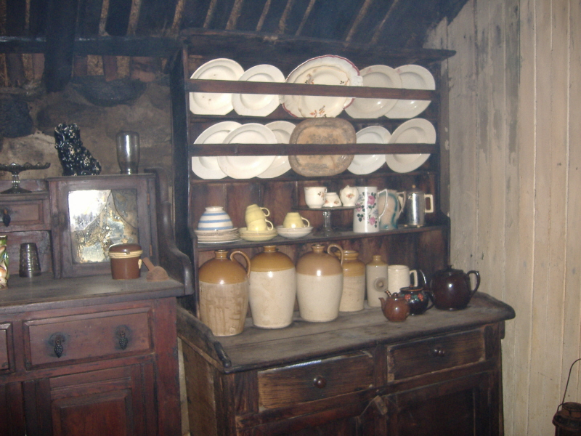

Fig. 3

On examination of a wide range of Barvas Ware it is clear that some was intended for use, (indeed some seem to have been used), and others were clearly made solely as curiosities. Some of the teapots, all of which possess ungainly proportions, have a spout which is solid and therefore purely decorative.

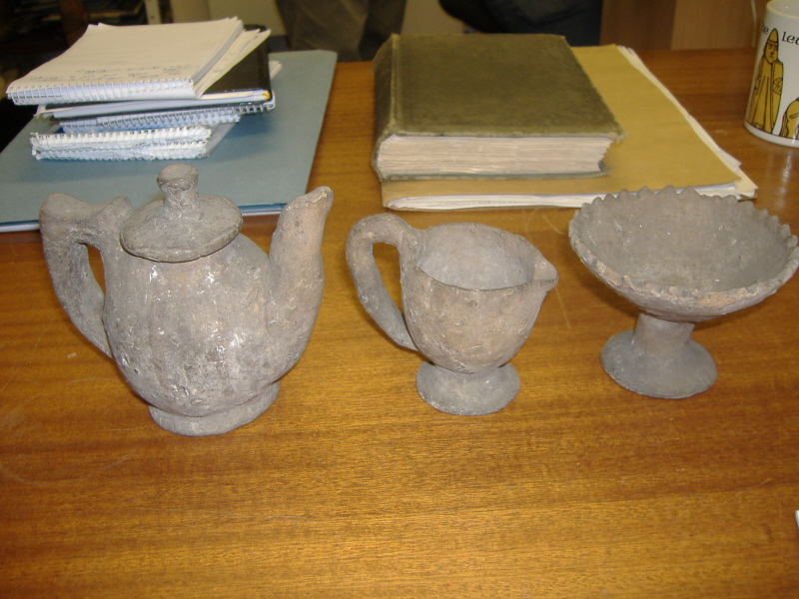
Fig. 4

Others have working spouts with some attempt at pierced areas for straining tea, most of which were very poorly executed and would not have worked. The other indication of use was in the condition of the milk sealed surface. If they had not been used the surface had a white, powdery finish, reminiscent of a thin wash of slip or engobe.

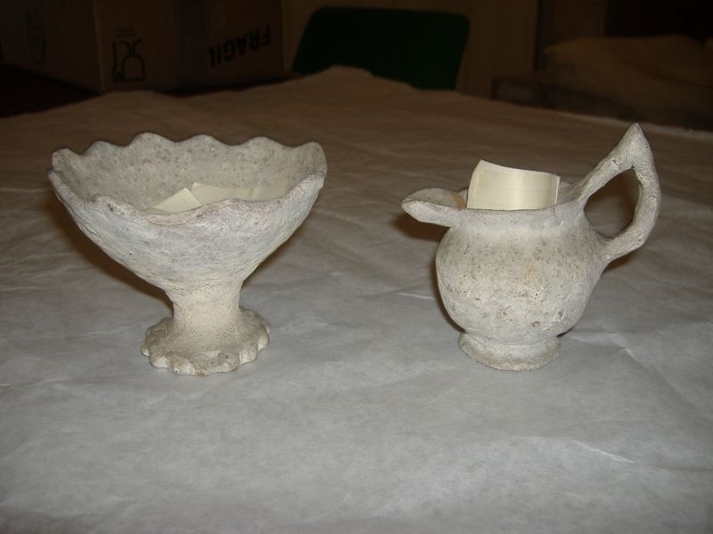

Fig. 5

Where the objects appear to have been used the milk seal has completely disappeared leaving a light brown or ochre coloured surface with the qualities of fine sand paper and the gritty property of the clay very apparent.
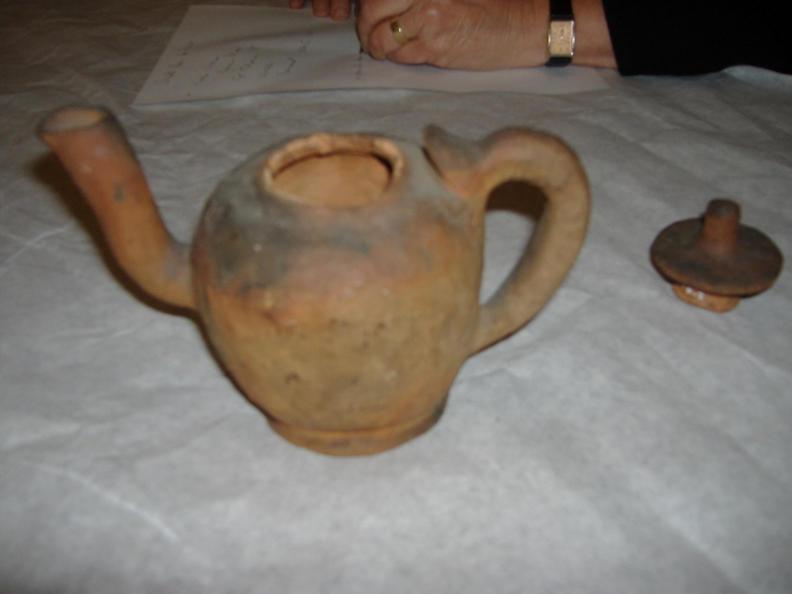
Fig. 6

I can only presume that the larger teapots with functioning spouts were intended for use and as the demand for ‘souvenir’ type tea sets increased, they became more compact and neatly finished. Apart from the craggans, sugar bowls and vases, they almost all have the distinctive pointed handle, regardless of size and skill. There are rudimentary attempts at decoration. On the teapots there is evidence of relief work, with fashioned pieces of clay applied to the surface.

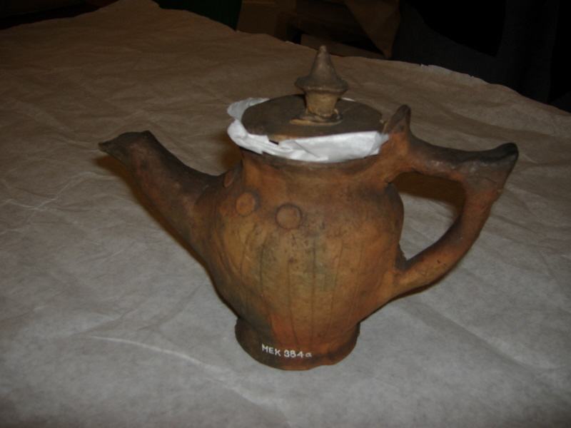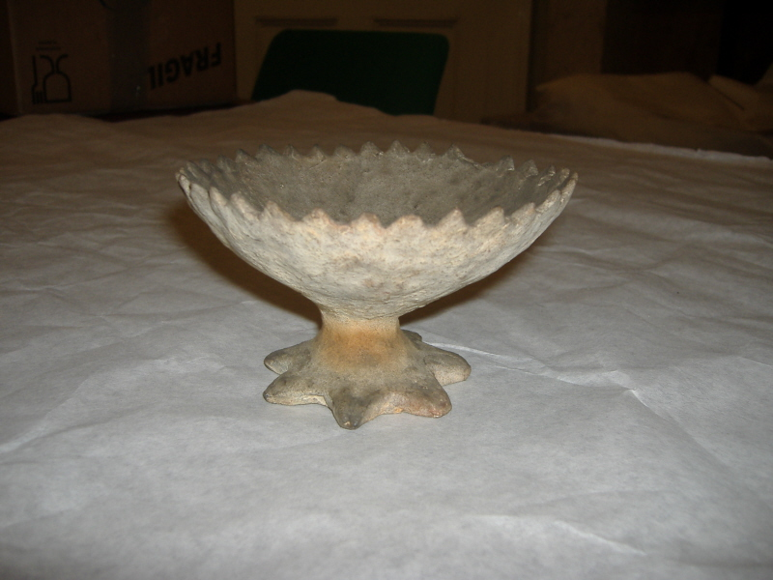

Fig.7 Fig.8

Many sugar bowls have a ‘pastry cutter’ edge which has a more uniform finish compared to other decoration. (see Fig.8) The milk jugs have a variety of form in the body and some decoration around the foot.(see Fig.9) The cups and saucers are the simplest objects with no decoration, the saucer flat, with a slightly upturned rim and no indentation for the cup to sit in.(see Fig.10).

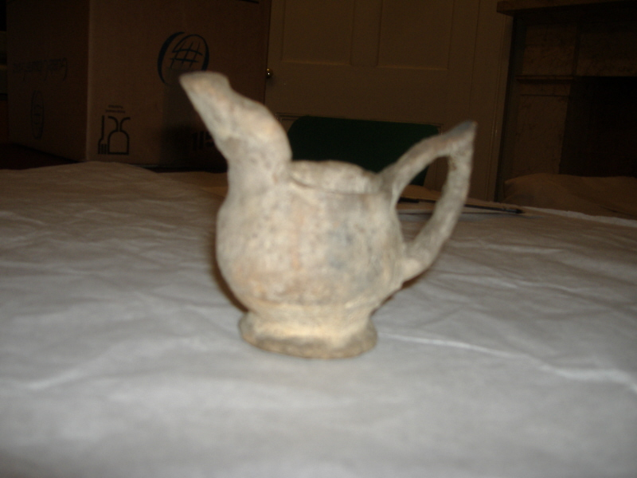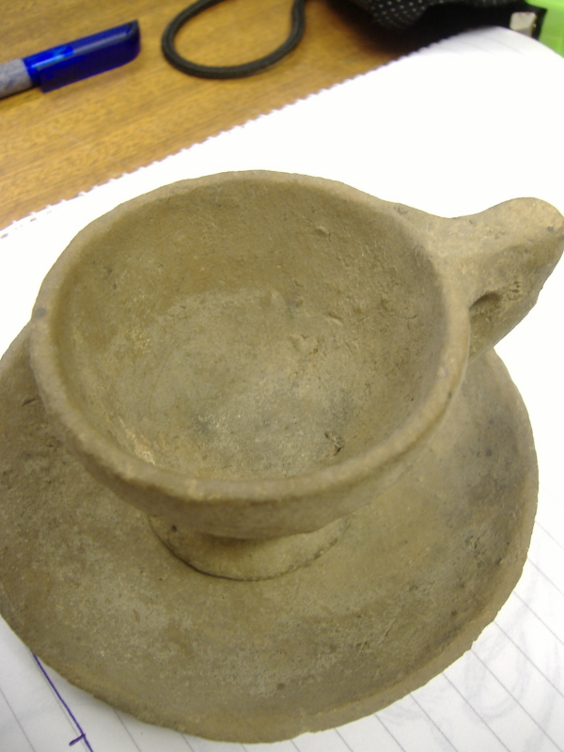
Fig. 9 Fig.10
The clay has clearly been left relatively unrefined. There are references as to how the women prepared their clay from two main sources, but Mitchell’s description of Mrs MacLeod is the most noted:

The clay she used underwent no careful or special preparation. She chose the best she could get, and picked out of it the larger stones, leaving the sand and the finer gravel which it contained.

Such an open-bodied, unrefined clay would be much less susceptible to thermal shock, and would be less likely to break in the centuries old system of firing.

Mitchell then goes on to describe the making and firing:

With her hands alone she gave to the clay the desired shape….. no aid from anything of the nature of a potter’s wheel. In making the smaller craggans, with narrow necks, she used a stick with a curve on it to give it form to the inside. All that her fingers could reach was done with them. Having shaped the craggan, she let it stand for a day to dry, then took it to the fire in the centre of the floor of her hut, filled it with burning peats, and built burning peats all around it. When sufficiently baked, she withdrew it from the fire, emptied the ashes out and then poured slowly into it and over it about a pint of milk, in order to make it less porous.

A set produced by Catriona McLean (daughter of Mary MacIver) was clearly made from a smoother bodied clay and is more refined than other Barvas Wares. Commissioned in 1935 by an archaeologist, Mr A.D.Lacaille, for the museum of the Wellcome Insitute, London, the set would have been one of the last pieces ever made (See Fig.11). It is noted that the MacIvers travelled four or so miles to collect their clay, where there were shielings. 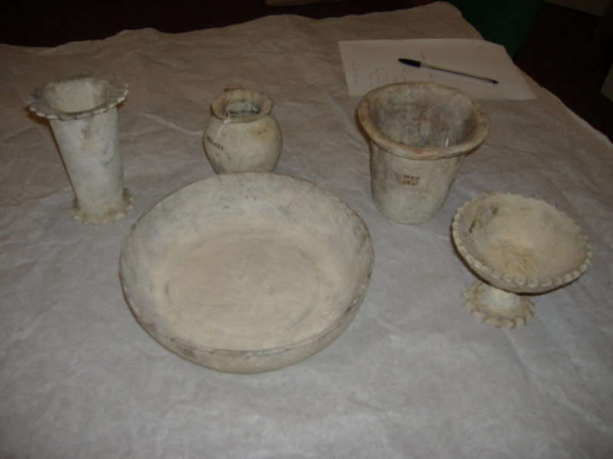

Fig 11.

Whether this was smoother than other clays or by the 1930s Catriona MacLean prepared her clay more thoroughly than those before her, is not clear, but as a group of objects they would not look too out of place in a gallery today. The unmarred milky finish and the relative simplicity of form produced, comparatively, quite skilfully, make these the most aesthetically pleasing of all the Barvas Wares I have studied. By the 1930s the making of pottery was purely a commercial venture and it would be interesting to compare the living and working conditions between Catriona MacLean and Flora MacDonald producing some seventy years earlier.

The letter from Mr Nicholson to the Reverend Dun is evidence of Flora MacDonald making craggans for sale in 1877. She would have been sixty-one, fourteen years after Mitchell’s visit. She obviously made craggans to order, which her daughter carried on doing but the only evidence of her tea set making is from the aforementioned interview with John MacDonald, (Flora’s grandson). According to relatives of the MacDonalds, Murdo MacIver from Park would visit to watch how things were made at the MacDonald croft. He took note and went home to explain the process to his wife Mary. It is probable that their pottery making was born out of the desire to sell. By the 1890s advertisements were placed in Edinburgh and London newspapers- the prices being:

Cups 6d
Saucers 6d
Egg cups 6d
Cream jugs 6d
Sugar bowls 6d
Teapots 2s
Crogans 1s
Vases 1s6d

On 5 August 1893 an article appeared in the Scottish Leader entitled ‘An Interesting Highland Industry’. It described Barvas Ware as a new industry run by ‘two old women’. They were not named anywhere in the article, so it is not possible to say whether it was the MacIvers embarking on their own business venture or whether it was a joint enterprise with the MacDonalds. Presumably Flora MacDonald had stopped making by then. Mary Murray, her daughter, made pottery as a spinster living in the original blackhouse behind the main house on the croft on which her brother lived (see Fig. 12). She married late in life but continued making into the 1930s, the last of generations of makers practicing an ancient tradition.

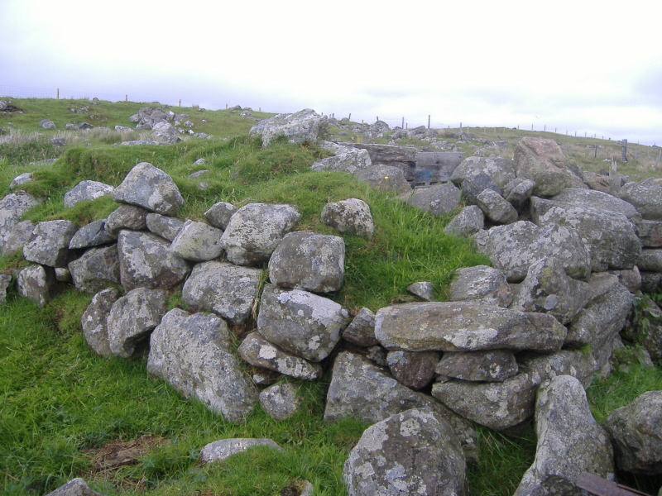

Fig 12.

The business venture came to an end when Catriona MacLean stopped making, also in the 1930s, a short-lived tradition of two generations of women but which brought to an end the making of pottery in that parish.

The article in the Scottish Leader described a large demand for the wares, commenting that the two old women set to

with a will. They monopolise the industry, supplying it to the merchants of Stornaway, through whom it reaches the outer world … the baptism of milk completes the simple process of manufacture, and the curious articles are sent into the world, where they fetch a good figure.

The article implied that it was quite a business, with far reaching distribution, but played on the quaintness and curiosity factor, having no reference to the makers other than describing them as ‘old’. It is quite possible that the anonymity of the women was of their own choosing. As well as various writing on the subject, a photograph was taken in 1907, by Reverend Edmund Quiggen, of pots being fired on the hearth, with no reference to the maker. Previously to that in 1901, an article printed in The Brick journal, stated that there had been some difficulty in persuading the women to have their photograph taken,

the women … participated in the old Highland superstition against photography … remembering the many tourists that had snapped them unawares ‘they didna want to be ridiculed’ .

(The authenticity of the women’s quote may be questionable as they were Gaelic speakers). They were eventually allowed to photograph the women but, again, there was no reference to the maker’s names. The article in The Brick (an archaeological periodical), very closely resembles the article in The Scottish Leader despite there being eight years difference in the publications. Both gave the impression of a thriving business, ‘quaint and queer’, but they did not comment on how it would have been just another aspect of women’s work on the croft – an activity undertaken in the evening whilst other women knitted or spun. There was little time or need for decoration or refinement of the pots. In the case of craggans, they could easily be replaced, sentiment and emotional attachment to the pots appears non-existent, individual maker’s identity held little currency within their own community and presumably the same attitude was adopted towards the Barvas Ware.

Crofting and the role of women
Pottery making had been the preserve of women for centuries in the Hebrides. Martin Martin commented on it in 1695, as did Arthur Mitchell nearly 200 years later stating that it was done by women in their own homes. However, as Hugh Cheape has pointed out

the making of crogans was an art and skill of women which has been disregarded, or under valued; there was no term in Gaelic for women crogan makers.

It is most likely that in the day to day running of the croft there was no room for ego, or time to step back and contemplate one’s work - inconceivable to myself as a maker. However, when viewed in the context of subsistence living, when the family’s survival is dependent on the hard work of every member, it is completely understandable. From the continuous burning of the peat fire (the centre of family life), to cutting the peats, working in the fields, tending the animals, butter and cheese making, rope making, net mending, corn threshing, spinning and weaving, amongst other activities, it would appear out of place to have such seemingly trivial concerns.

Crofting required a structured routine. Various tasks were specifically the domain of either men or women, and some activities required everyone’s effort. It is likely that pottery making was an evening activity after all the necessary daily tasks were done. With life so hard it was no wonder that when seasonal work opportunities arose, away from the islands that many men and significantly more women chose to go. During the nineteenth century the British fishing industry prospered and ‘following the herring’ became a seasonal fact of life. The men worked the boats whilst the women, yet again in the supportive role, gutted and packed.

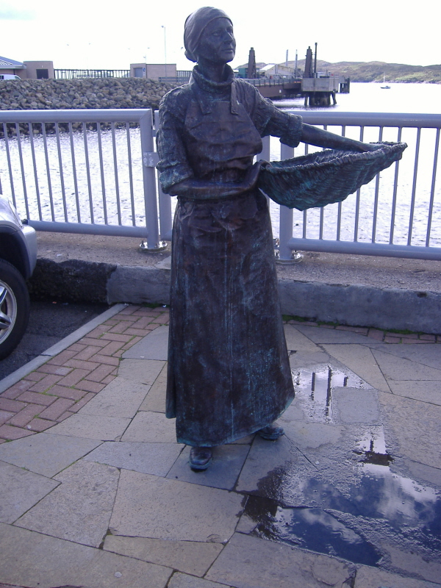
Fig. 13

This trend continued into the 1930s when machinery finally took over the work of the women. By then women were used to working away from the island and earning money. Many went on to enter domestic service in houses on the mainland.

It is difficult to know what impact any of this would have had on the Barvas potters, whether they were part of the seasonal migration or whether they chose to contribute to the economy by staying where they were. It is, however, safe to assume that whether through their own travels or those of other women in their community, they would have come across factory produced pottery being brought back to the island. The fact that the women would have had factory wares to hand that they could loosely copy is, therefore, established. The argument as to whether the tea sets were actually initially used in their homes, or produced solely for the tourists, is something that is unlikely to be resolved. By the time of Mitchell’s visit, tea would have been drunk in some island homes, but it would have been some ten years later that tea drinking became a common habit. However, what is more pertinent is at which point the tea sets became as significant as craggans in the history of pottery making in the Hebrides?

The outside world
Arthur Mitchell would have had a greater interest in the craggans than the tea sets, given his interests. Prior to the development of the steamship connection in 1851, the motivation for outsiders to visit the islands would have been of an academic nature. Renowned writers such as Thomas Pennant, Dr Samuel Johnson and James Boswell, as Cheape states, would have had an influence on growing numbers of visitors, and with the steamship came ‘tourists of the new moneyed classes, scholars and antiquaries mingled with the sportsmen and the curious’.

Visitors, therefore, arrived in much greater numbers than ever before and with new agendas.

It opened up the islands to the curious gaze of this new breed of person, the tourist, and it bought scholars and archaeologists to explore what was perceived to be an ancient world peopled by a society that the new Victorian moneyed classes might consider primitive. The fact that the inhabitants spoke another language widened the gulf between Victorians and Gaelic islanders.

By the mid 1800s the interest in indigenous peoples of foreign lands was further sparked by the 1859 publication of Charles Darwin’s The Origin of Species, prompting changing attitudes in the scientific world. The appeal of the Hebrides would have been the apparent wealth of anthropological subject matter on the mainland’s doorstep. Arthur Mitchell and his companion, Captain Thomas, so inspired, would have arrived on Lewis, hungry for the undiscovered and the obscure.

The thrill for Mitchell to come across the stonebreaker on the side of the road and to then be invited into to an island home to witness the making of such a vessel must have been intoxicating. The windowless interior of the blackhouse, the peat fire with no escape route for smoke, the whole environment so alien to his own experience must have, inevitably led to a romanticism of the situation. His observations of Mrs MacLeod sitting in her ‘squalid and wretched house’, led him to remark

the woman who fashioned the cow and the craggans was full of shrewdness, a theologian in her way … and quite able to become well versed in a score of other things if the need and opportunity had arisen.

Mitchell’s writings are more calculated and have a more academic tone some years later in the publication of The Past in the Present 1880, in which he states

That the very rudest known form of an art may coexist in a nation with the highest- Wedgewood in Etruria and the MacLeods of Barvas.
That persons capable of immediately receiving the very highest culture may practice an art just as it is practised by the most degraded savages of whom we have any knowledge.

Mitchell’s interest was always anthropological not consumerist. He was concerned with attempting to link similarities between the homes, the lifestyles and working implements of the islanders with those of the bronze and iron ages. In the case of craggans it is quite plausible and as Cheape points out

he demonstrated that their late survival was due to their suitability to the special circumstances of their generally disadvantaged, though far from unintelligent users.

The tea sets obviously did not have the same history as the craggan, but by association, became regarded as part of the traditional pottery making in Barvas. The selling of tea sets after Mitchell’s visit was such that by 1878 a short written inclusion in Jewitt’s The Ceramic Art of Great Britain, as Cheape acknowledges, stimulated a much greater interest and demand for Barvas Wares by describing them in terms ‘designed to excite the serious collector: “Handmade pottery is still made and used in all its primitive simplicity”’ .

Jewitt then continues by mentioning an MP friend who had ordered a Barvas Pottery tea set some ten years earlier,

The remarkable thing is that the pottery is distinctly copied, rudely enough, from modern pottery. The forms are ordinary Tottenham Court Road forms, and their continued use in an island with a regular steamboat service from Glasgow strikes me as very curious.

There is no mention of craggans in this endorsement and by the time Barvas Ware is advertised nationally the ancient craggan had been demoted to seventh in a list of eight, (shown earlier) behind all the components of a tea set. The pottery production appears to have taken a full turn from craggans being the predominant product with tea sets an aside, to tea sets becoming the main marketing focus. The article written for The Scottish Leader, 1893, mentions the craggans stating that ‘this unique product can boast an ancient history, though its modern development is of recent origin’.

The remainder of the article relates to the tea sets and is not particularly complimentary in its description,

The teapot is a clumsy article, dumpy and quaint, with the lid sitting on unsteadily as a hat on a drunken man. The spout is wonderfully made being short and thick with a peculiar turn at the point.

The article concludes with the statement that the wares were out of keeping with modern times. The irony being that they were almost certainly at that point produced exclusively for tourists by which time the islanders would be drinking their tea from imported factory china. As early as the late 1800s craggans and Barvas Wares were being donated to museums by the islanders, who had no use for them at home. It is apparent from my own and others research that by the beginning of the twentieth century interest had gradually declined. Hugh Cheape states

Barvas Ware continued to be made in some quantities until the time of the First World War, a trade sustained, according to a parliamentary report of 1902, by ‘curio hunters’.

Barvas Ware was nationally exhibited in Edinburgh in 1908 and Glasgow in 1911. By the time Cecil Curwen published his article in Antiquity in 1938, only three years after Catriona MacLean had sold the set to Lacaille, the tone implied that the production of pottery had ceased years before. He commented that ‘a quaint feature’ of Barvas pottery is that it latterly began to show ‘Staffordshire influence’, which ultimately became its downfall.

This consisted in the production of crude imitations of teapots, teacups, sugar basins etc., in the local unglazed fabric, and it was a feature which heralded the complete extinction of this remarkable survival.

Curwen also commented on the fact that with Woolworths established in Stornaway it was not surprising that he failed to trace a single specimen of Barvas Ware on the island.
However it would have been of little surprise to the islanders. The assumption that they were in daily use was misplaced. The Scottish Leader commented that ‘It does not seem to be meant for extensive use though perhaps it might do for a few “calleachs” in the wilds of the Highlands’.

Presumably if mainland purchasers of the wares knew they were produced solely as curios, they would not have been so willing to part with their money. Perhaps the thought that they were used in island homes made them more desirable as ‘curiosities’, satisfying the colonial attitudes of those that bought them, a notion perpetuated by the occasional article such as the above.

Conclusion
Curwen’s article in Antiquity identifies the beginning of the end as being when the women began to produce the imitation Staffordshire Ware, when in fact it could be argued that the tea sets sustained the ‘industry’ for many decades after its ‘sell by date’, by making them for export. If Mitchell had not written about the pottery in the first place how much recorded knowledge would we have of it and how much was his intervention catalytic to this turnaround? His writing is invaluable evidence of what was, even then (1863) a dwindling activity, until outside interest rejuvenated the production.

I am in no way suggesting there was anything Machiavellian about Murdo MacIver’s intentions, but there is no doubt he saw potential in selling pottery to tourists. As a family they sought out a good supply of clay, and were willing to travel four miles to collect it. Historically women became potters, dependent on whether their croft had good clay, and its continuity dependent on whether there was a daughter to pass on the skills to, however MacIver’s intervention created a new direction. Flora MacDonald perhaps had an inherent sense of truth to the material. The rough and ready making and decoration of craggans emphasised the qualities of the clay in its more or less found state and involved minimal preparation. To then use the same material in an attempt to imitate high fired, factory produced, bone china forms using such a low firing, impure, earthenware body was never going to be satisfactory aesthetically or functionally. As with any imitation it would never be as good as the original. Its relative success was because of where it was made and its association with a ‘primitive’ culture made it all the more desirable.

The dresser in the island home displayed the treasures. Items brought back from their travels or imported goods took pride of place, not the craggans or the Barvas tea sets. In fact, there appears to have been very little emotional attachment to hand-made pottery within the families of the makers, evidenced by the fact that relatives had very little, if any, knowledge of pottery ever being made. At the time they were objects of necessity and when they could be replaced by something new and more efficient there seems to have been no difficulty in letting go.

Choosing to buy imported goods or crockery ‘bought for best’ when seasonally working on the mainland, islanders selected elements of material culture that suited their changing life patterns and aspirations. The Barvas tea sets would never have had such status nor would they have been a necessity and they certainly did not have widespread use, even on such a small island. It is little wonder that their history has become marginalised coupled with the fact, as pointed out by Jane Webster , that much of the island’s cultural history is associated with poverty and, until recently, has been rather forgotten than revered. There is an irony in the fact that as the ‘primitive’ tea sets were exported for display to rich Victorian homes, factory produced china was being imported to adorn the dressers of the islanders.

The anonymity of the potters is, perhaps only a contemporary issue. People within the Barvas community would have known who made the craggans. It would be just another aspect of crofting, part of the local bartering for goods and skills such as carpentry and tailoring. However, the ritual of the baptism in milk was something that set the activity apart, all the more memorable when it took place at an evening ceilidh , but it was still just an element of women’s work. There is, however, a growing recognition of women’s role within crofting communities and of the significance of material culture to Hebridean heritage. The centuries of craggan making has its place in the history of Lewis as does the sub-culture of the tea sets which represents a small but significant development – a window of opportunity catering for a new market - seized and exploited for around eighty years.

BIBLIOGRAPHY
The Brick, May 1901.
Cheape, H. ‘Crogans and Barvas Ware: Handmade Pottery in the Hebrides’, Scottish Studies, 31, 109-128. Canongate Academic, Edinburgh. 1993.
Cheape, H. ‘The Role of Women in Traditional Celtic Society in Scotland’, Journal of Agricultural Museums, vol 20. 1987.
Cheape H. ‘Food and Liquid Containers in the Hebrides: A Window on the Iron Age’, chapter from Fenton, A. and Myrdal, J.A Window on the Iron Age, Edinburgh, John Donald, 1983.
Cheape H. ‘Crogans and Barvas Ware Pottery in the Islands’, Stornaway Gazette, week ending 22 January 1983.
Cooper D. Road to the Isles: Travellers in the Hebrides 1770-1914, Edinburgh, Macmillan, 1979.
Curwen E.C. ‘The Hebrides: A Cultural Backwater’, Antiquity, vol.22, 1938.
Fenton A. The Arnol Blackhouse, The Isle of Lewis, Historic Scotland, 2005.
Hirst C. Back to the wind, front to the sun:The Traditional Croft House, Isle of Lewis, The Island Book Trust, Port of Ness, 2005.
Hutchison R. The Soapman-Lewis, Harris and Lord Leverhulme, Edinburgh, Birlinn, 2005.
Jewitt L. The Ceramic Art in Great Britain, Chicheley, Minet P.B, 1971 edition.
MacDonald C. Lewis:The Story of an Island, Dublin, Acair Ltd, 1998.
MacDonald D. Tales and Traditions of the Lews, Edinburgh, Birlinn, 2002.
Maclean C.I. The Highlands, Edinburgh and London, Mainstream Publishing, 2006 edition.
Mitchell A. The Past in the Present, Edinburgh, David Douglas, 1880.
Parman S. Scottish Crofters: A Historical Ethnography of a Celtic Village, Fort Worth, USA, Ted Buchholz, 1990.
Ross W.A and H.R. A Little Book of Gaelic Proverbs, Belfast, Appletree Press, 1996.
The Scottish Leader 5th August 1893
Thompson F. Lewis and Harris: History and Pre-History, Edinburgh, Luath Press, 2005.
Webster J. ‘Resisting Traditions: Ceramics, Identity, and Consumer Choice in the Outer Hebrides from 1800 to the Present’, International Journal of Historical Archaeology, vol 3, no1, March 1999.
Vincentelli M. Women Potters, Transforming Tradition, London, A&C Black, 2003.
www.culturehebrides.com

Acknowledgements:
Barvas and Brue Historical Society, letter from Nicholson to Rev Duns, newsletter and DVD of Sue Blair and others recreating Barvas craggans. Interview with Mary MacDonald, published by the Stornaway Gazette, undated.
Borgh Pottery, Lewis
Nan Eilann Museum Stornaway, notes on collection of Barvas Ware, information on Crogans and Barvas Pottery from Mr Malcolm MacIver, 31st May 1988.
National Museum of Scotland.
The MacDougall Collection, comments from John MacDonald, grandson of Flora MacDonald, May 1971.
Author’s photographs with kind permission from the Museum of Scotland, Edinburgh.
Ken MacDougall.

Notes ? ‘Craggan’ and ‘crogan’ have the same meaning. Both are used in the texts referred to throughout this article.
See Moira Vincentelli, Women Potters Transforming Traditions, London, A&C Black, 2003, p.19.
An example of a peat fired hearth can be found at the Arnol Blackhouse Museum, on the Isle of Lewis.
www.culturehebrides.com/archaeology/craggan/
Ibid.
Ibid. A model cow (amongst several animals collected but since broken and lost), made by Mrs McLeod was illustrated in The Past in The Present.
Hugh Cheape, ‘Crogans and Barvas Ware: Handmade Pottery in the Hebrides’. Scottish Studies (v. 31), Edinburgh, Canongate Academic, 1993. p112.
www.culturehebrides.com/archaeology/craggan/
Letter dated 20 September 1877 from Mr D.I Nicholson to the Rev Dun, copy acquired from Ken MacDougall.
www.culturehebrides.com/archaeology/craggan/
Interview between a Reverend Norman MacDonald and John MacDonald, May 1971. Information provided by the MacDougall Collection, Oban.
Information on Crogans and Barvas Pottery from an interview with Mr Malcolm MacIver, 31st May 1988, conducted by Hugh Cheape. Acquired from NanEilann Museum Stornaway.
Interview with Mary MacDonald from the Stornaway Gazette, undated.
Ibid.
Ibid.
Flora MacDonald’s great, great grandson, interviewed by author, June 2006.
Christine Hirst . Back to the Wind, Front to the Sun. The Traditional Croft House, Port of Ness, Isle of Lewis, The Island Book Trust, 2005, p88.
www.culturehebrides.com/archaeology/craggan/
Ibid.
Blackhouse- the traditional thatched houses on the island, replaced from 1930 onwards with two storey ‘whitehouses’.
Image shows ruins of Flora MacDonald’s original blackhouse.
The Scottish Leader, 5 August, 1893.
The Brick, May 1901
www.culturehebrides.com/archaeology/craggan/
Hugh Cheape, ‘Crogans and Barvas Ware’ p.126.
See Hugh Cheape, ‘Food and Liquid Containers in the Hebrides’, A.Fenton and J Myrdal, A Window on the Iron Age, Edinburgh, John Donald, 1983, p15.
Hugh Cheape ‘ Food and Liquid Containers’, p11.
Ibid, p12.
www.culturehebrides.com/archaeology/craggan/
Arthur Mitchell, The Past in the Present , Edinburgh, David Douglas, 1880.
Hugh Cheape ‘Food and Liquid Containers’.p15
Ibid, p14
?L. Jewitt The Ceramic Art of Great Britain, Chicheley, P.B Minet, 1971 edition.
Scottish Leader 5 August 1893.
Ibid.
Hugh Cheape, ‘Crogans and Barvas Ware’, p118.
Antiquity, 1932, xii, p282.
Gaelic for ‘old women’.
Scottish Leader 5 August 1893.
Jane Webster, ‘Resisting Traditions:Ceramics, Identity, and Consumer Choice in the Outer Hebrides from 1800 to the Present’. Published in The International Journal of Historical Archaeology, Springer Netherlands, v. 3, no.1, March 1999.
Ceilidh: a ‘get together’.

